**Pseudocode:**

1. Create a dictionary named 'course_rooms' with course numbers as keys and room numbers as values.  
- Create a dictionary called 'course_instructors' with course numbers as keys and instructor names as values.  
- Create a dictionary named 'course_times' with course numbers as keys and meeting times as values.  
  
2. Loop Until Valid Input: - Start an infinite loop.  
- Ask the user for input.  
- Instruct the user to input a course number (such as CSC101 or NET110).  
- Check if the course exists:  
- If the course number appears in the 'course_rooms' dictionary:  
- Print the course number.  
- Output the corresponding room number from 'course_rooms'.  
- Select the appropriate instructor from 'course_instructors'.  
- Print the meeting time from 'course_times'.  
- Exit the loop.

- If the course number is invalid:

- Display an error message: "Invalid course number. Please try again."

- Continue looping to ask for input again.

**Source code:**

# Dictionaries for the course info

course_rooms = {

"CSC101": "3004",

"CSC102": "4501",

"CSC103": "6755",

"NET110": "1244",

"COM241": "1411"

}

course_instructors = {

"CSC101": "Haynes",

"CSC102": "Alvarado",

"CSC103": "Rich",

"NET110": "Burke",

"COM241": "Lee"

}

course_times = {

"CSC101": "8:00 a.m.",

"CSC102": "9:00 a.m.",

"CSC103": "10:00 a.m.",

"NET110": "11:00 a.m.",

"COM241": "1:00 p.m."

}

# Loop to keep asking the user until a valid course is entered

while True:

course_number = input("Enter a course number (e.g., CSC101, NET110): ").strip()

if course_number in course_rooms:

print(f"\nCourse Number: {course_number}")

print(f"Room Number: {course_rooms[course_number]}")

print(f"Instructor: {course_instructors[course_number]}")

print(f"Time: {course_times[course_number]}")

break

else:

print("Invalid course number. Please try again.\n")

**Screenshot of application executing the script:**

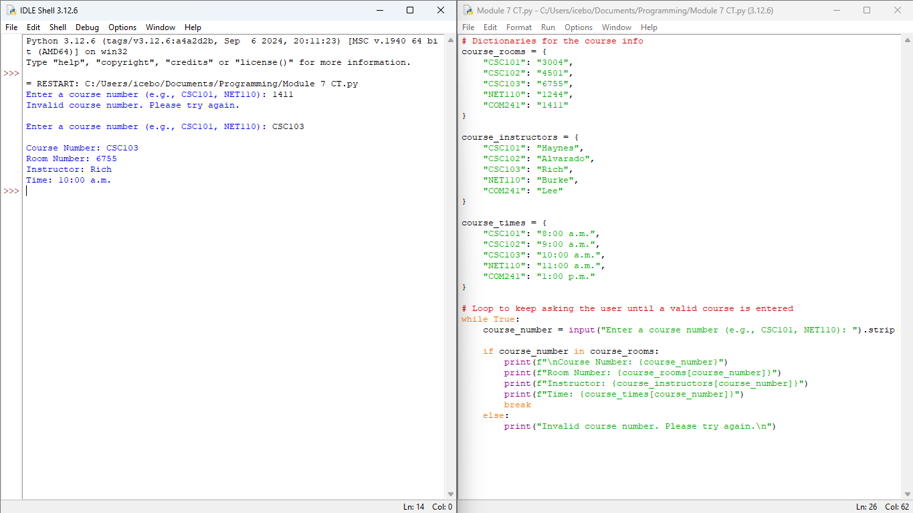

**GIT Repository link:**

<https://github.com/giftataylor/Module-7-CT>